​​1DV503/1DT903 Database Technology and Modeling
William Schröder
School of Computer Science, Physics
and Mathematics, Linnaeus University, Sweden
ws222gx@student.lnu.se

Task 1. The Hospital database (25 points)

1.1 Identify all entities and their attributes from the description of database requirements using the following Table template:
Entity | Attribute | Attribute Type | Key Attribute | Value type of  attributes (type,  NULL/NOT  NULL, Unique)
DEPARTMENT | DepartmentID | Simple | TRUE | Unique, Integer
 | DepartmentName | Simple | FALSE | Unique, Name
 | HeadPhysician | Simple | FALSE | String, NULL
PHYSICIAN | PhysicianID | Simple | TRUE | Unique, Integer
 | PhysicianName | Simple | FALSE | String, NULL
 | PhoneNumber | Simple | FALSE | String, NULL
 | PhysicianAddress | Multivalue | FALSE | String, NULL
PATIENT | PatientID | Simple | TRUE | Unique, Integer
 | PatientName | Composite | FALSE | String, NULL
 | PatientAddress | Multivalue | FALSE | String, NULL
 | InsuranceCode | Multivalue | FALSE | String, Name
NURSE | NurseID | Simple | TRUE | Unique, Integer
 | NurseName | Simple | FALSE | String, NULL
 | NursePhoneNumber | Simple | FALSE | String, NULL
 | NurseSpecialization | Simple | FALSE | String, not null
 | NurseStartTime | Composite | FALSE | DateTime, NULL
 | NurseEndTime | Composite | FALSE | DateTime, NULL
ROOM | RoomNumber | Simple | TRUE | Unique, String
 | RoomType | Simple | FALSE | String, NULL
 | AvailabilityStatus | Simple | FALSE | Boolean, not null
MEDICATION | MedicationID | Simple | TRUE | Unique, Integer
 | AtcCode | Simple | FALSE | String, NULL
 | MedicationName | Simple | FALSE | String, NULL
PROCEDURE | PatientID | Simple | FALSE | String, not null
 | ProcedureName | Simple | FALSE | String, not null
 | ProcedureCost | Simple | FALSE | Float. NULL
 | Duration | Simple | FALSE | String, NULL
TEST | RecordedID | Simple | TRUE | String, NULL
 | TestDate | Composite | FALSE | DateTime, NULL
 | TestType | simple | FALSE | String, NULL
 | TestResult | Simple | FALSE | String, NULL
APPOINTMENT | StartDate | Composite | TRUE | DateTime, NULL
 | EndDate | Composite | TRUE | DateTime, NULL
 | RoomNumber | Simple | FALSE | String, not null
 | PatientID | Simple | FALSE | String, not null
 | PhysicianID | Simple | FALSE | String, NULL
 | NurseID | Simple | FALSE | String, NULL

1.2 Identifying the relationship between entity sets using the following table template:
Entity A | Relationship name | Entity B | Cardinality Ration  (1:1,1:N,N:1,M:N) | Attribute of Relationship Types | Justify your decision
DEPARTMENT | HEAD | PHYSICIAN | 1:1 | HeadPhysician | The department has one unique head physician  and the head physician has  one department which it is the head physician of
DEPARTMENT | HAS_WORKING | PHYSICIAN | 1:N | DepartmentID | Each deparment can have many physicians but  each physician can only have one department
PHYSICIAN | CREATES | APPOINTMENT | 1:N | PhysicianID | Each physician can create many appointments  but a appointment can only have one physician
PHYSICIAN | SETS | PROCEDURE | 1:N | PhysicianID | Each physician can set many diffrent procedures  but each procedure can only have one physician
PHYSICIAN | PRESCRIBES | MEDICATION | 1:N | PhysicianID | Each physician can give many diffrent medication  but only that medication is assoiciated with one  physician
PATIENT | TAKES | TEST | 1:N | PatientID | Each patient can take many diffrent tests but only  one test is assoiciated with each patient
PATIENT | ASSIGNS_TO | APPOINTMENT | 1:N | PatientID | Each patient can have multiple diffrent appointments  but only one specific appointment can be to the patient
NURSE | ASSISTS | APPOINTMENT | 1:N | NurseID | Each Nurse can assist many diffrent appointments  but one appointment can only have one nurse
NURSE | ON_CALL | ROOM | 1:N | RoomNumber | Each nurse can be on call for many diffrent rooms but  a room can only have one nurse
MEDICATION | USED_IN | PROCEDURE | M:N | MedicationName  ProcedureName | Each medication can be in many diffrent procedures  and each procedure can be used with many diffrent  medications
PROCEDURE | INVOLVES | TEST | M:N | ProcedureName  TestType | Each procedure can have multiple tests and each test  can be used in many diffrent procedures

1.3 Design an ER schema for hospital database based on information provided in task 1, and entities defined in 1.2 with relationships defined in 1.3.
The ER schema should contain entities with their corresponding attributes, key attributes of each entity, relationship types, and their corresponding cardinality ratio.
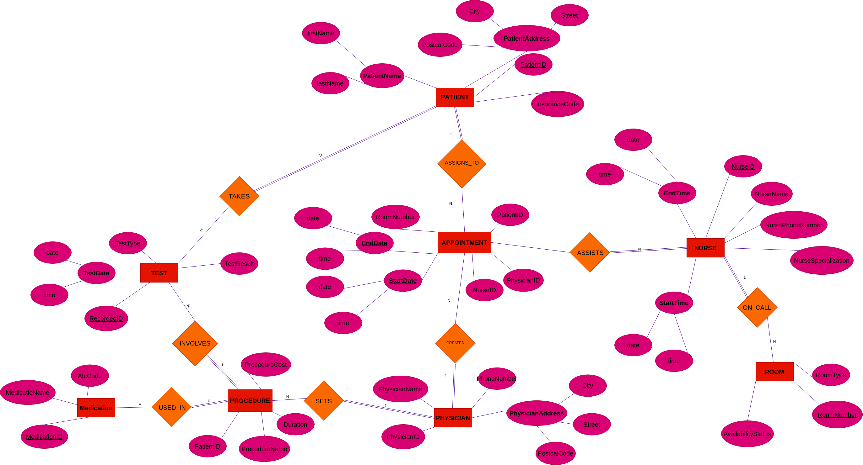

Task 2 Conference Review Database (25 points)

2.1 Identify all entities and their attributes from the description of Conference review database requirements using the following Table template:

Entity | Attribute | Attribute Type | Key Attribute | Value type of attribute (type, min, max, unique, NULL/NOT NULL)
Entity 1 | Attribute 1 | Simple and Derived | true | String, not null
 | Attribute 2 | Composite | false | Integer, not null
 | Attribute 3 | Multivalued | false
… | … | …. | … | ….

2.2 Identifying the relationship between entity sets using the following table template:

Entity A | Participation Entity A | Relationship name | Particpiaiton  Entity B | Entity B | Cardinality Ration  (1:1,1:N,N:1,M:N) | Attribute of Relationship Types | Justify your answer
Entity 1 | Total | Reviewing | Partial | Entity 2 | 1:N | Comment

2.3 Design an ER schema for review database based on information provided in task 2, and entities defined in 2.1 with relationships defined in 2.2. You are free to make additional assumptions if you feel that some information is missing. Make sure to document all assumptions that you make. Please justify your assumptions.

Task 3. Bank database (25 points)
Consider the ER diagram shown below for part of a BANK database. Each bank can have multiple branches, and each branch can have multiple accounts and loans. Provide answers on the following statements:
- List a strong (nonweak) entities in the ER diagram
Answer: BANK, ACCOUNT, CUSTOMER, LOAN,
- Is there a weak entity? If so, give its name, partial key, and identifying relationship (owner entity)
Answer: BANK_BRANCH, Branch_no, Has_branches

- What constraints do the partial key and the identifying relationship (owner) of the weak entity have in this diagram
Answer: The constraints for the partial key and the identifying relationship is that “Branch_no” is not accessible to by the other tables, which can make it so if a developer or a user want to use that “Branch_no” to connect something else it would not be able to. Which in turn can make creating a Unique “Branch_no” not possible and therefor a total new entity would have to get created.

- List the names of all relation (entity) and specify the (min, max) constraint using the total/partial participation of an entity in a relationship (on both sides of the relation: left and right). Justify your answer.

Entity name | Relationship  name | (min,max) | Justify your answer
Bank | Has_Branches | (1,N) | ….
Bank_Branch | Has_Branches | (1,1) | …
…. | …

Task 4. Airport Management database (25 points)

4.1 Given the constraints shown in the ER schema below, respond to the following statements with True, False, or Maybe.

N | Statement | True/False/Maybe | Justify your answer
1 | Every pilot has been a passenger in some flight. | True
2 | Every flight has at least one deadheading pilot.
3 | Every flight has at least 2 pilots.
4 | Every pilot has flown at least 2 times.
5 | There are tickets that do not belong to any flight
6 | Some airline does not have flights
7 | Some flight does not have assigned aircraft
8 | Each flight has a departure and arrival airport assigned
9 | A passenger can be a pilot
10 | Passengers can buy one ticket for the flight
11 | There are tickets that do not have a class type (Economy, Business, etc.)
12 | There are some tickets without payment
13 | There are some flights without tickets
14 | There are some aircraft that are not assigned to a flight
15 | Some airlines do not have any flights.

